‘Go Green on Lamma Island’ Programme Series
(1): Renewable Energy

Field Trip Activities on Lamma Island

Name: ________________( ) | S. _______ | Date: ____________

Stop 1 Viewing at Lamma Power Station
- Write the letters in the space provided to show the components of power station in Figure 1.
Components of Power Station:
- Coal-fired Generating Units | - Gas-fired Combined-cycle Generating Units | - Oil-fired Generating Units
- Coal Yard | - Ash Lagoon | - Transport jetty
Figure 1 Components of Power Station
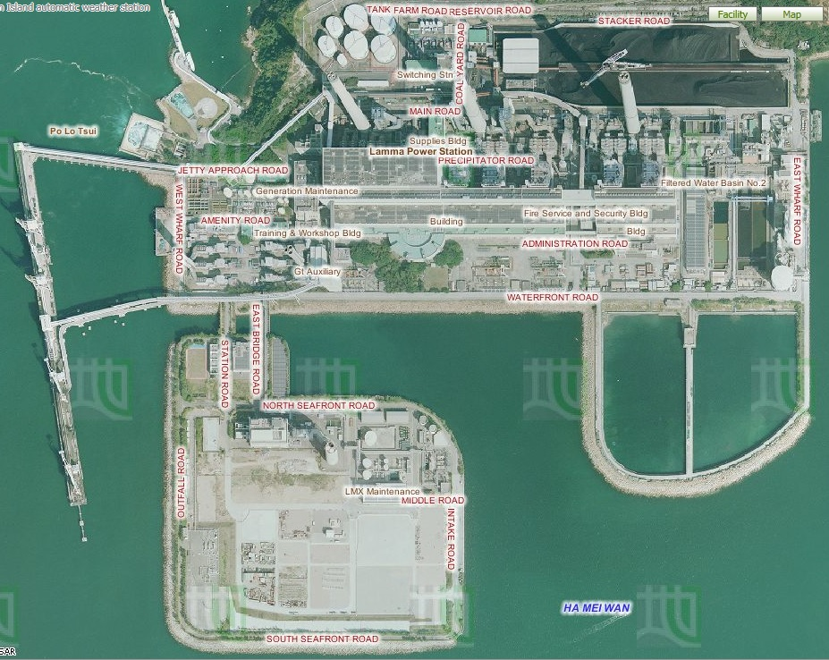
2. f
4. e
6. b
5. c
3. d
1. a
Lamma Power Station Extension

Aerial Photos from Lands Department
- Describe and explain the locational advantages of the power station.
Locational characteristics | Reasons
Is it located near the coast?  Yes | - Easier import of fuel by cheap sea transport.  - Need water for cooling.
Is it sheltered by hills?  Yes | - The impact caused by adverse weather condition is reduced.
Is it near the residential areas?  No | - High risk of fire explosion.  - Air pollution is serious.

- Table 2 shows the capacity of the Lamma Power Station.
Table 2 Capacity of the Lamma Power Station in 2013

 | Number of units | Capacity of each unit (MW) | Total capacity (MW)
Coal-fired Generating units | 3 | 250 | 750
 | 5 | 350 | 1750
Oil-fired Generating Units | 4 | 125 | 500
 | 1 | 55 | 55
Gas-fired Combined-cycle Generating Units | 1 | 335 | 335
 | 1 | 345 | 345
Solar Power System |  |  | 1
Lamma Winds |  |  | 0.8
Total |  |  | 3736.8
Source: Hong Kong Electric
https://www.hkelectric.com/en/MediaResources/Documents/LPS_2014.pdf
- What energy source (Hint: a type of fuels) is mainly used in the electricity generation? What do they include? Are they renewable?
Fossil fuel is mainly used. It includes coal, petrol and natural gas. They are not renewable.
- (b) Among these fuels, which one is mainly used to generate electricity in
- the power station? Which one has been increasingly used to generate
- electricity recently? (Hint: Think about what kind of generating unit
- has been built in the newly-reclaimed area)
- (b) Among these fuels, which one is mainly used to generate electricity in
- the power station? Which one has been increasingly used to generate
- electricity recently? (Hint: Think about what kind of generating unit
- has been built in the newly-reclaimed area)
- Among these fuels, which one is mainly used to generate electricity in
- the power station? Which one has been increasingly used to generate
- electricity recently? (Hint: Think about what kind of generating unit
- has been built in the newly-reclaimed area)
(b) Among the fuels mentioned in (a), which one is mainly used to generate electricity in the power station? Coal.
(c) What kind of fuels has been increasingly used to generate electricity recently? (Hint: Think about what kind of generating unit has been built in the newly-reclaimed area?) Natural gas.
4. Observe the power station. Does the power station cause air pollution? If yes, what kinds of air pollutants are released?
Yes, carbon dioxide, sulphur dioxide and nitrogen oxide.
5. Figure 3 shows the amount of air pollutants emitted from coal-fired and gas-fired generating units respectively when the total electricity generation in the year 2012 would increase by 2.57 times compared with that in 1990.
Figure 3 Amount of Air Pollutants Emitted from the Coal-fired and Gas-fired Units
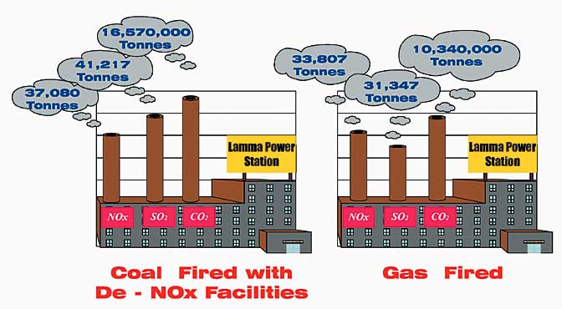

Source: Environmental Protection Department, HKSAR Government
http://www.epd.gov.hk/eia/operation/english/chapter05_4.html
- Why does the power station cause climate change?
The burning of fossil fuels for generating electricity will emit large amount of greenhouse gases (CO2). The greenhouse gases trap heat in the atmosphere and intensify greenhouse effect, causing global warming.
- More generating units will be built to generate more electricity in future. Explain why.
It is because of population growth and rapid economic development.
or any reasonable answers.
- Which kind of fossil fuels, coal or natural gas, should be more widely-used in the new generating units? Explain why.
Natural gas: cleaner energy, thus reducing pollutants and greenhouse gases. This helps mitigate climate change.
- Do you think that using a mixture of different types of fossil fuels only can help to minimize climate change in future? Why?
No. Natural gas can reduce carbon emission but the increase in demand of electricity still causes the combustion of more natural gases, resulting in more carbon emission.
or any reasonable answers.

Stop 2 Lamma Winds
Is the use of renewable energy a way out in Hong Kong?

- What types of renewable energy are used at this site?
Wind and solar energy.
- Why is it suitable to set up the wind turbine at this site? Give five reasons.
- Far away from ecological sensitive area
- Wind speed sufficient for electricity generation
- Accessible by road
- Open land without obstacles to block the wind
- Proximity to existing power grid
- Far away from residential areas
Is it easy to find similar site to build wind farm in Hong Kong? Why?
It is not easy because it is hard to find a large and open land without obstacles to block the wind.
- Collect the data at the tower base of the wind turbine and complete the following table.
Date & time | 12 Jan 2017 at  10:34 p.m.
Present wind speed | 5.9 m/s | m/s
Present power output | 198.1 kW | kW
Cumulative electricity generated | 9442719 kWh | MWh
Amount of carbon dioxide (CO₂) saved | 7868932 kg | tonnes
Remarks: The units of cumulative electricity generated and amount of carbon dioxide saved shown on HK Electric’s website are different from those shown at the tower base of the wind turbine.
What is the relationship between wind speed and power output?
Positive relationship.

- In 2013, the electricity consumption was 44.21 billion kWh in Hong Kong. Do you think that this wind turbine generates a lot of electricity? Give evidence to support your answer.
No, the amount of electricity generated by wind turbine is very small. It only accounts for very low percentage of total electricity consumption.
Explain why this wind turbine cannot be designed to produce a lot of electricity.
- Wind condition is unstable.
- Wind speed is not very high.
- Moderate height restriction.
- Current technology is limited.
or any reasonable answers.

- By observation, list the environmental problem(s) caused by the wind turbine.
It may threaten birds and create visual and noise pollution.
- Should different types of renewable energy, particularly solar energy and wind energy, be further developed in Hong Kong?
Each group will be assigned one of the following roles. Collect the information from the exhibition panels for discussion.
Role | Tasks
Government | Discuss why different types of renewable energy should be further developed in relation to existing environmental problems
Spokesman from a power company | Discuss whether the development of different types of renewable energy is cost-effective
Environmentalist | Discuss the negative impact of the development of different types of renewable energy on the environment
Urban planner | Discuss the problems in the selection of suitable sites for the development of different types of renewable energy
Spokesman from Department of Energy | Discuss whether different types of renewable energy can give abundant and reliable energy supply in Hong Kong and their energy efficiency
Your role: Any reasonable answers.
Your opinion: Any reasonable answers.
- Do you agree that the renewable energy should be further developed in Hong Kong as a sustainable measure against global warming? Why?
Strongly disagree Disagree Agree Strongly agree
Give at least three reasons:
Any reasonable answers.
- The use of technical measures, like fuel mix and renewable energy, seems not to be the most sustainable way to combat climate change caused by power station. Then what else can we do to solve this problem?
- People can develop green habits and reduce waste disposal.
- People can reduce energy consumption and choose energy-efficient appliances.
or any reasonable answers.

